Manual: How to use the Unsupervised Image Classification Model

**Dear reader, this document serves as a manual for the use of the Unsupervised Image Classifier that has been used to distinguish WT mice from mice that suffer from Williams syndrome. I will show you screenshots of the script with additional information. This script has been written in the Python programming language. Therefore, it is necessary to install Python on the computer in order to run the script. I recommend to install Anaconda which is distributer that contains many useful programs. Spyder IDE is one of those and is very easy to work with.**

1. Before running the script, make sure that the script is located in the same folder as the subfolders with the data. This is essential as the script assumes that the data is present in the same folder. The name of the script is **unsupervised_image_classification.pyimage_classification.py.**

In order to use this script, you have to open the script in an IDE.

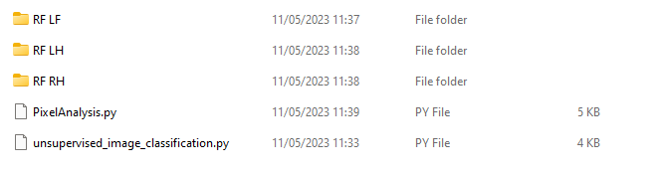

1. Next, before running the script, make sure that you press the option **Set console working directory** as this fixes the location of the working directory.

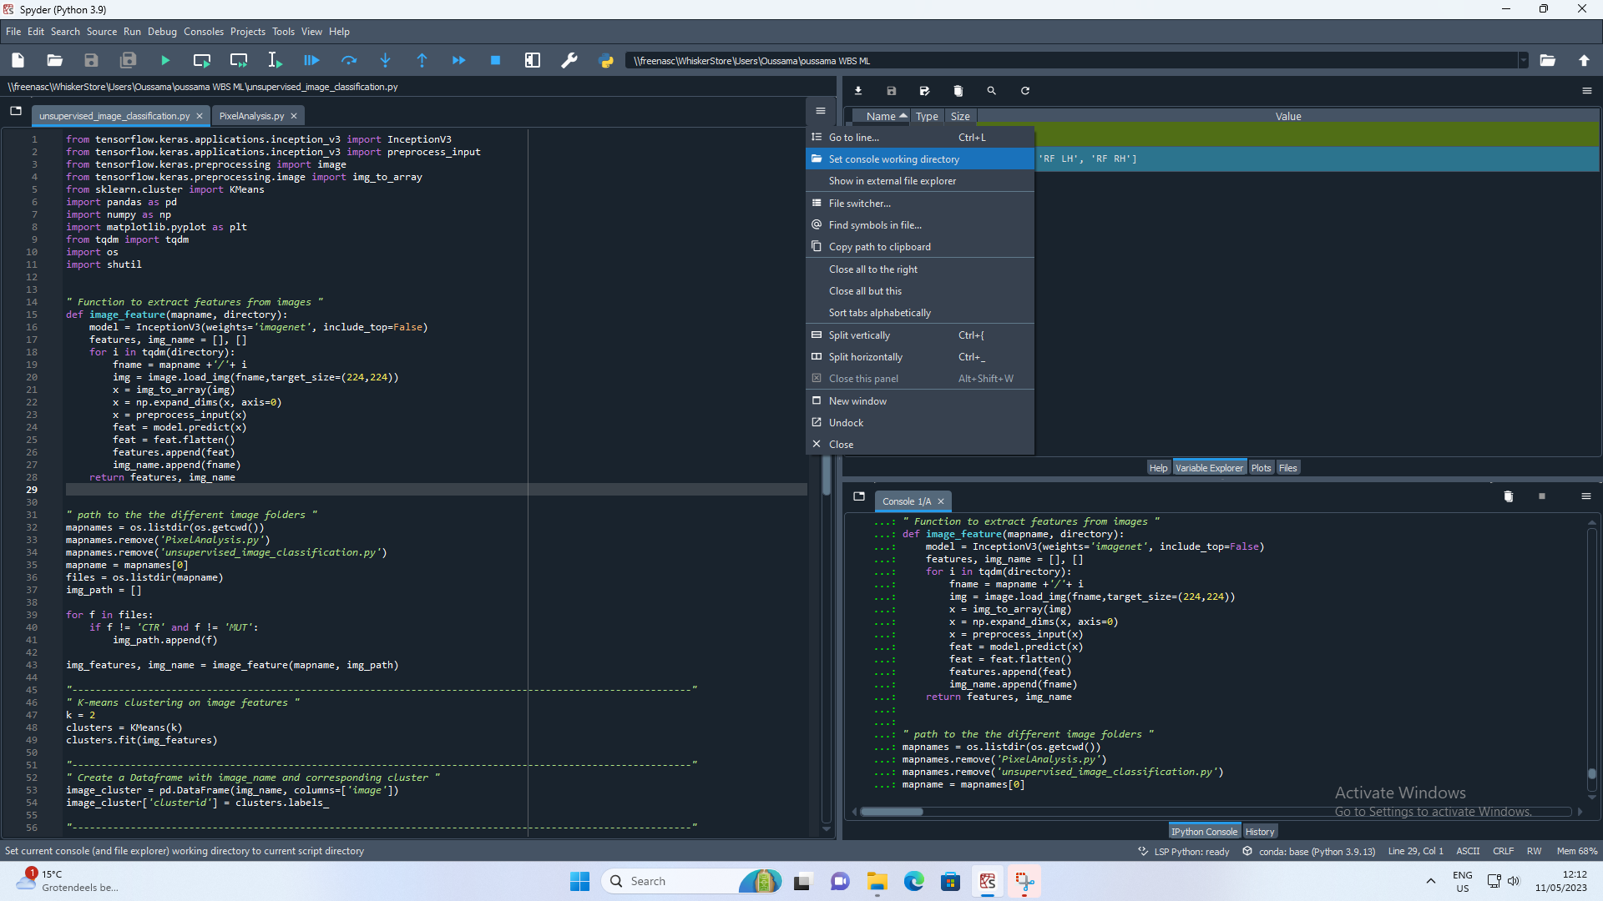

1. Go to line 35. There you find the variable **mapname**. This variable determines which data you are working with. In particular, this variable indicates the name of the subfolder that you want to analyze. The subfolders are referred to by numbers and they are numbered according to their relative location with respect to each other in the folder. In Python, the numbering starts with 0. In the example above, the number 0 is assigned to the subfolder *RF LF* as this is the first subfolder that is found in the folder. The number1 is assigned to *RF LH* and the number 2 is assigned to *RF RH*. If you want to change the subfolder that is indicated by **mapname**, you just have to change the number in the code **mapname = mapnames[0]**.

Voorbeeld van afbeelding

1. Select everything except for line 101 and press **F9**. After doing this, the following steps will be performed:
   1. The images will be separated by the model in two clusters: *cluster_0*  and cluster*_1*. This is done by the function **separation**.
   2. After separating the images in the two clusters, two subfolders will be constructed in the subfolder that you’re working in (that you have indicated with the **mapname** variable): *cluster_0 and cluster_1.*
   3. Lastly, a plot will be shown on your screen where you see an overview of the images in cluster_0. This image is also saved in the subfolder as *RESULTS-CLUSTER0*.
2. Select only line 101 and press F9 again. This will generate an overview of the images in cluster_1. This plots is also automatically saved in the subfolder that is indicated by **mapnames**. Note: make sure that you run line 101 **after** line 100 and not at the same time. If they are run at the same time, the two plots will mix and they will become a mess. So make sure that you run line 101 separately.

This is the end of the manual!

Have fun with Machine Learning :)